ALU UVM DESIGN REQUIRMENTS PDF

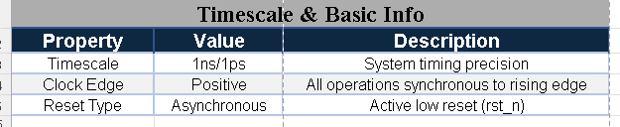
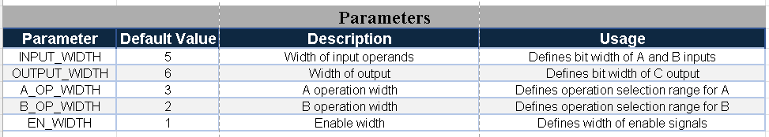
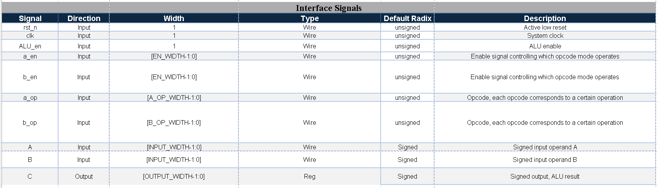

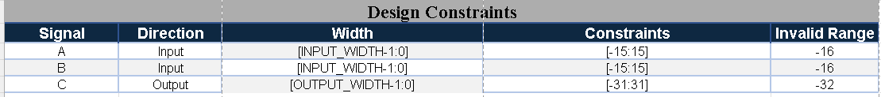

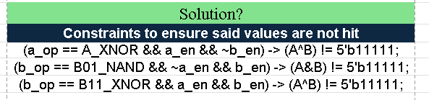

ALU UVM DESIGN REQUIRMENTS PDF
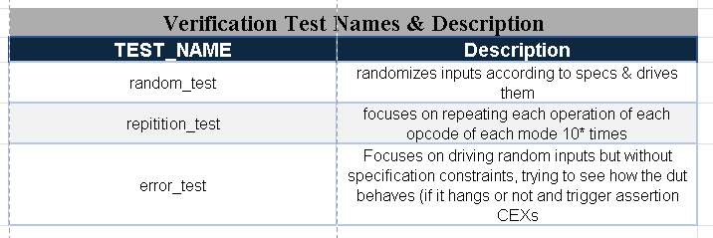

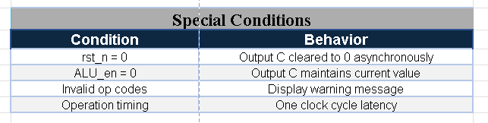

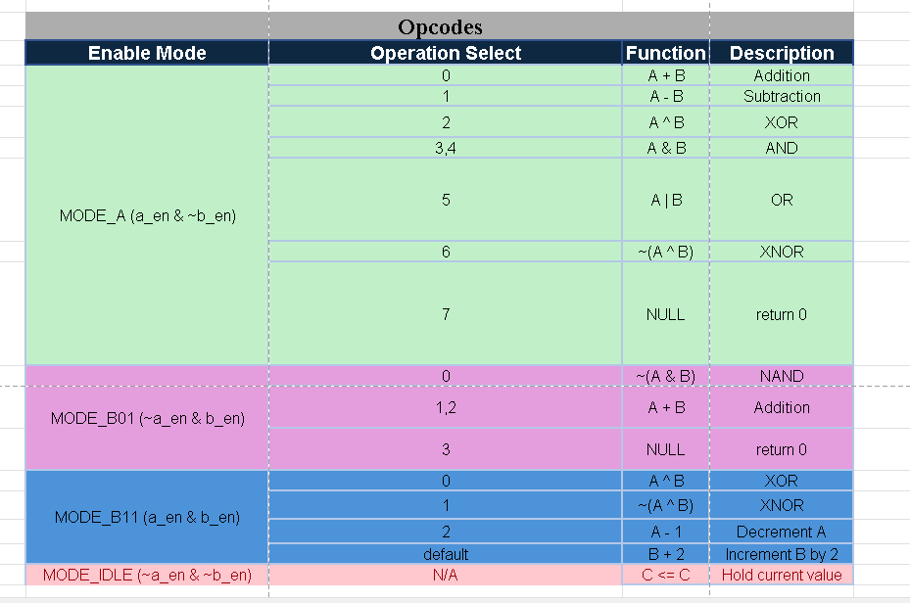

ALU UVM DESIGN REQUIRMENTS PDF

